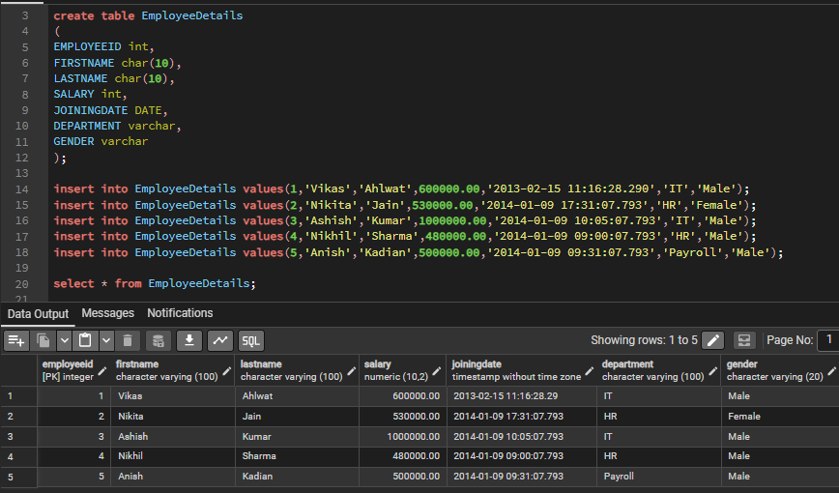
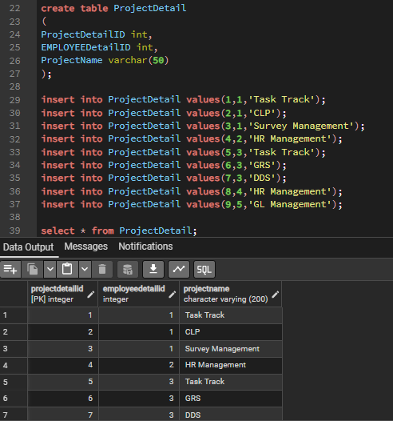

1. Write the query to get the department and departmentwise total(sum) salary from EmployeeDetails table?
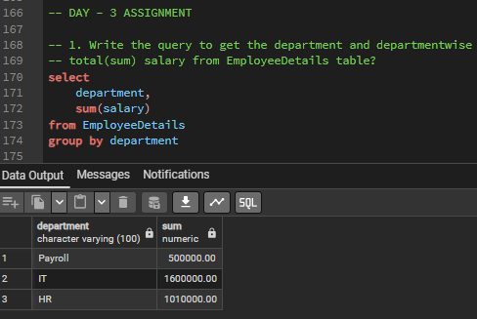
2. Write the query to get the department and department wise total(sum) salary, display it in ascending order according to salary?
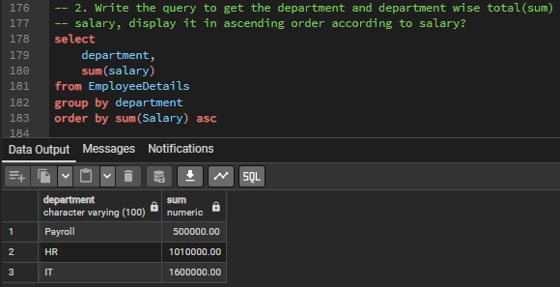

3. Write the query to get the department and department wise total(sum) salary, display it in descending order according to salary?
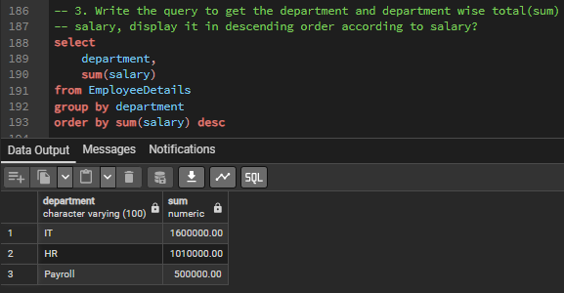

4. Write the query to get the department, total.no.of.departments total(sum) salary with respect to department from Employee Details table
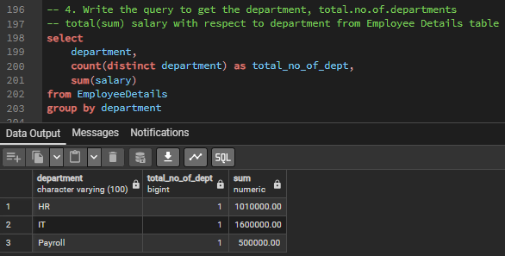

5. Write the query to get department wise average salary as well max salary from Employee detail table order by salary asc?
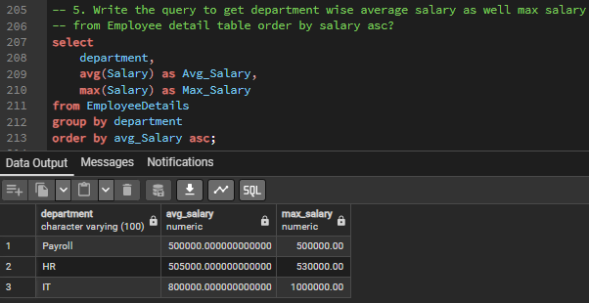

6. Write down the query to fetch project name assign to morethan one employee
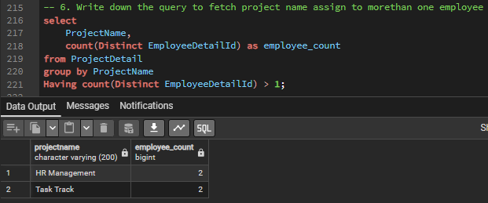

7. write down the query for roll up and cube commands on employee Table?

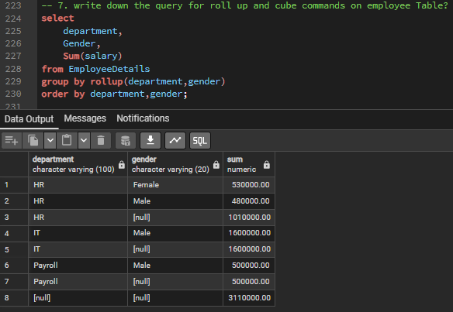
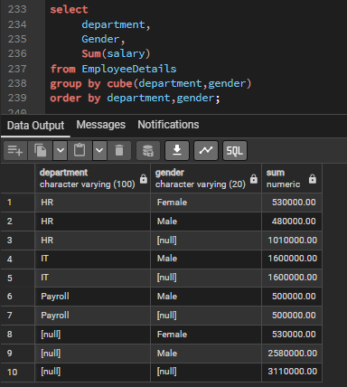

8. Write down the query to fetch the rows only top 5 from employee?
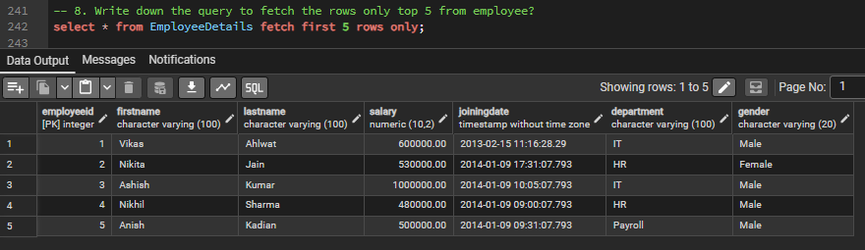

9. write down the query to get the common and duplicates records from mentioned above tables?
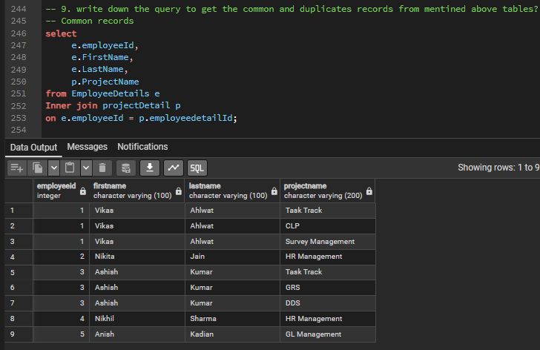
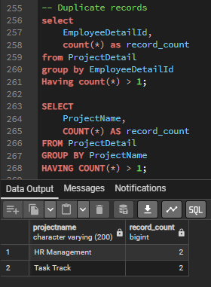

10. write down the query to get non-duplicates and unique records from mentioned above table?
